**“Object Oriented Programming’’**

**Lab Assignment No 3**

**8**

**th**

**May,**

**2025**



**Submitted To:**

**Muhammad Shahid**

**Submitted By:**

**Fateh Ali** (FA24-BCS-032)

Department **of Computer Science**

COMSATS University Islamabad

Lahore Campus

**Lab Assignment 3**

Main Class:

public class Main {  
 public static void main(String[] args) {  
 Shape[] shape = new Shape[20];  
 Shape2D shape2D;  
 Shape3D shape3D;  
  
 Shape2D circle1 = new Circle("Circle",true, 2, new Point(0,0));  
 System.*out*.println(circle1.area());  
  
 Shape2D rectangle1= new Rectangle("Rectangle",true, 2, 3, new Point(3,4));  
 Shape2D rectangle2= new Rectangle("Rectangle",true, 4, 5, new Point(4,5));  
 Shape2D rectangle3= new Rectangle("Rectangle",true, 5, 6, new Point(5,6));  
 System.*out*.println(rectangle1.area());  
 System.*out*.println(rectangle1.perimeter(2,3));  
  
 Shape3D sphere1 = new Sphere("Sphere", 2);  
 System.*out*.println(sphere1.area());  
 System.*out*.println(sphere1.volume());  
  
 Shape3D cube1 = new Cube("Cube", 3);  
  
 shape[0] = cube1;  
 shape[1] = circle1;  
 shape[2] = rectangle1;  
 shape[3] = sphere1;  
 shape[4] = cube1;  
 shape[5] = circle1;  
 shape[6] = rectangle2;  
 shape[7] = cube1;  
 shape[8] = sphere1;  
 shape[9] = cube1;  
 shape[10] = circle1;  
 shape[11] = sphere1;  
 shape[12] = rectangle3;  
 shape[13] = sphere1;  
 shape[14] = cube1;  
 shape[15] = cube1;  
 shape[16] = circle1;  
 shape[17] = rectangle1;  
 shape[18] = sphere1;  
 shape[19] = cube1;  
  
 ShapeUtils shapeUtils = new ShapeUtils();  
 shapeUtils.displayShape(shape);  
  
 shapeUtils.updateLength(shape);  
 System.*out*.println("After Updating Length of Rectangles\n");  
 shapeUtils.displayShape(shape);  
  
 shapeUtils.*drawDrawables*(shape);  
  
 Rectangle r = (Rectangle) rectangle1;  
 System.*out*.println("Rectangle Is Intersecting:"+ shapeUtils.*isIntersectWithRectangles*(shape,r));  
  
  
 }  
}

Output Screenshot 1:

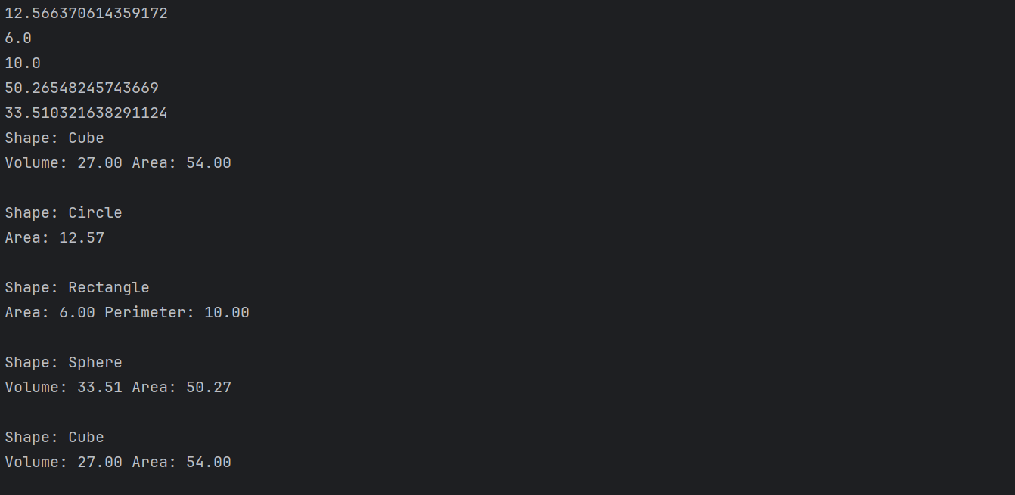

Output Screenshot 2:

Output Screenshot 3:

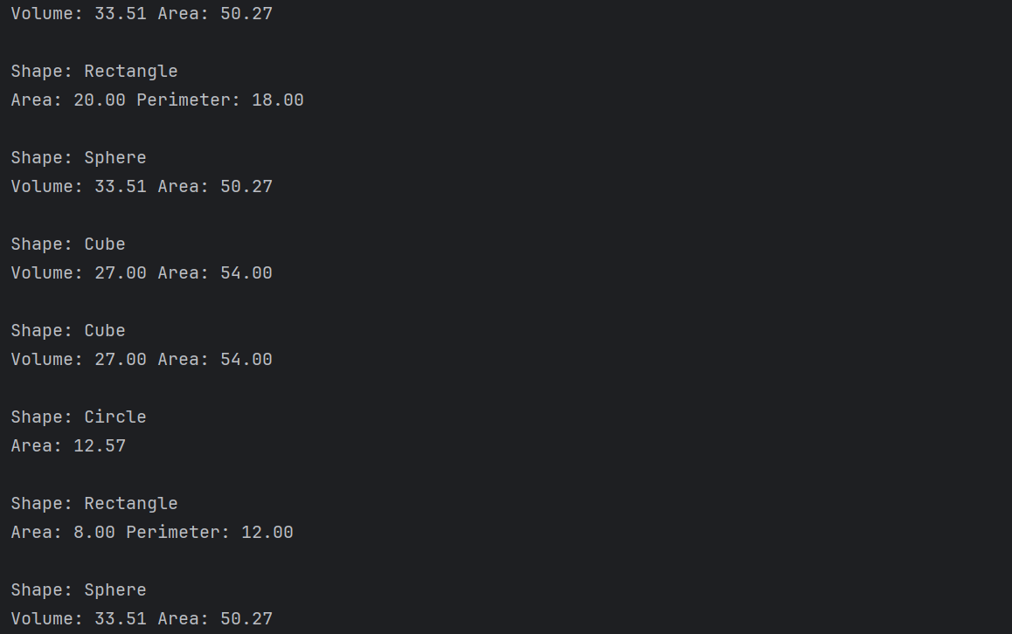

Output Screenshot 4:

Output Screenshot 5 (Intersecting Rectangle):

